Kavya SampathKumar Power BI Assignment 2
Create a Calculated Column for 'Category Type': Add a calculated column in the Order Details table that combines the 'Category' and 'Sub-Category' columns into a single 'Category Type' column.
Category Type = CONCATENATE('Order Details'[Category],"-"&'Order Details'[Sub-Category])

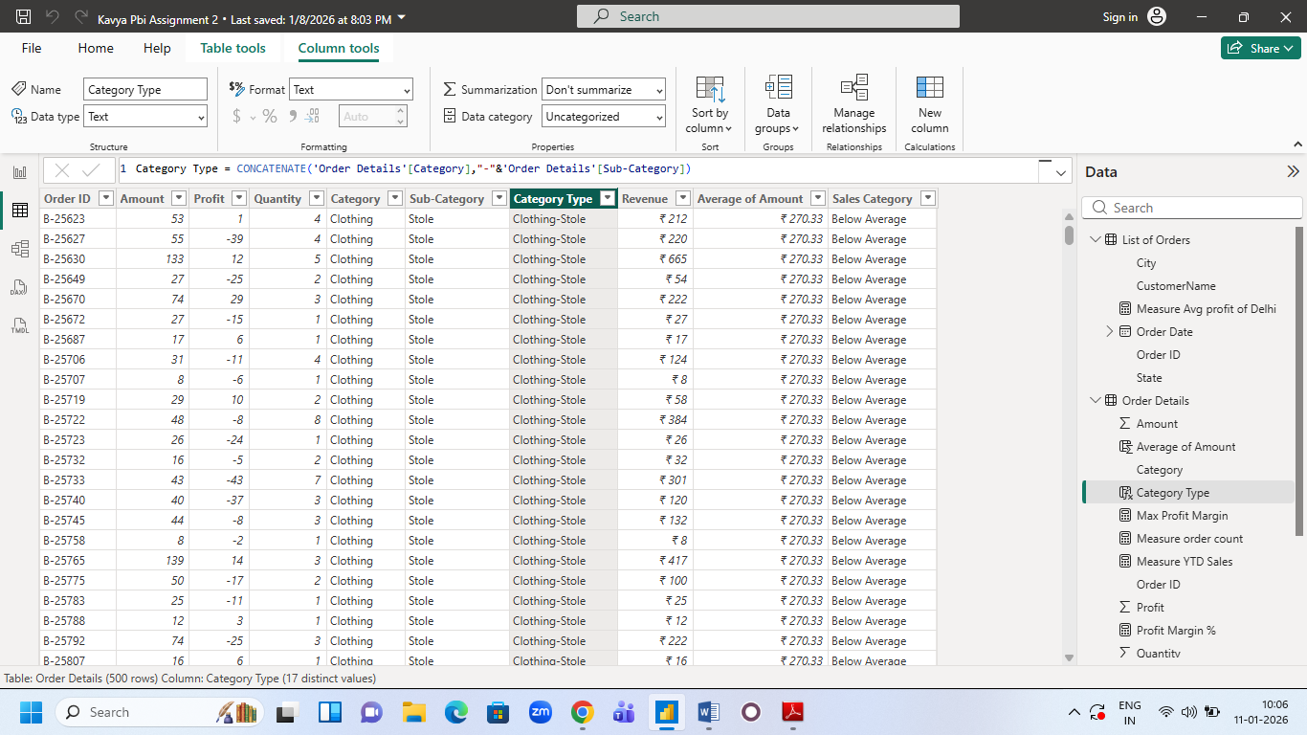

Calculate Revenue per Order in Order Details Table: Create a calculated column in the Order Details table to compute the revenue (Amount * Quantity) per order.
Revenue = 'Order Details'[Amount]*'Order Details'[Quantity]
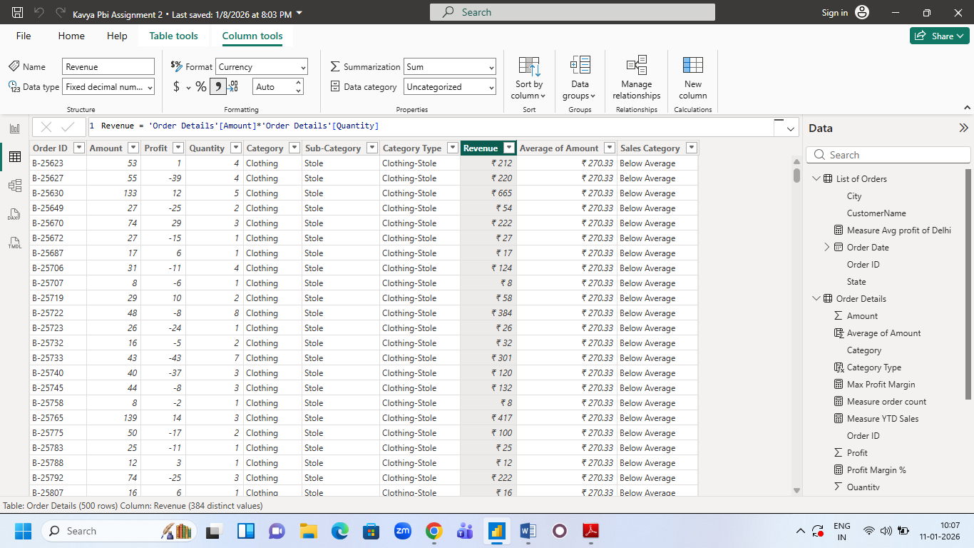

Create a Calculated Column to Categorize Sales: Add a calculated column named ‘Sales Category’ in the Order Details table that categorizes each order as 'Above Average' or 'Below Average' based on the Amount value.
Sales Category = IF('Order Details'[Amount]>'Order Details'[Average of Amount],"Above Average","Below Average")

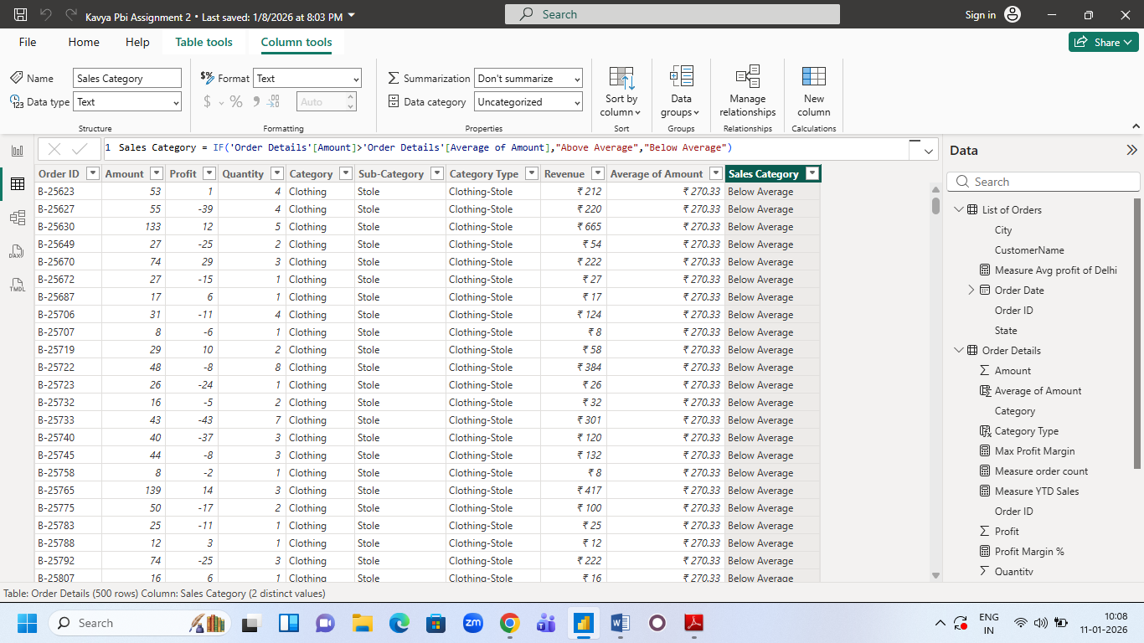

Calculate Order Count: Define a measure to count the total number of orders in the Order Details table.
Measure order count = COUNT('Order Details'[Order ID])
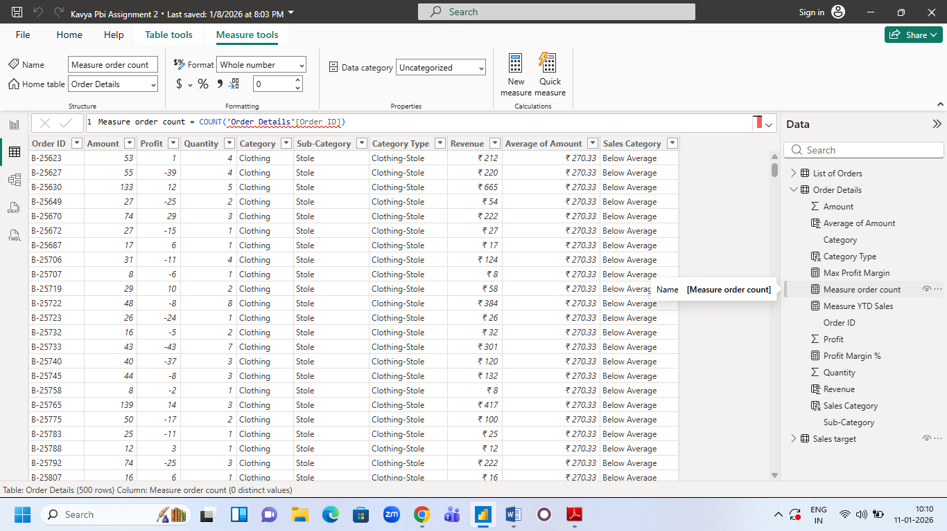

Calculate Average Profit in Delhi: Create a measure to calculate the average profit for orders placed in Delhi. Measure Avg profit of Delhi = CALCULATE(AVERAGE('Order Details'[Profit]),'List of Orders'[City]="Delhi")

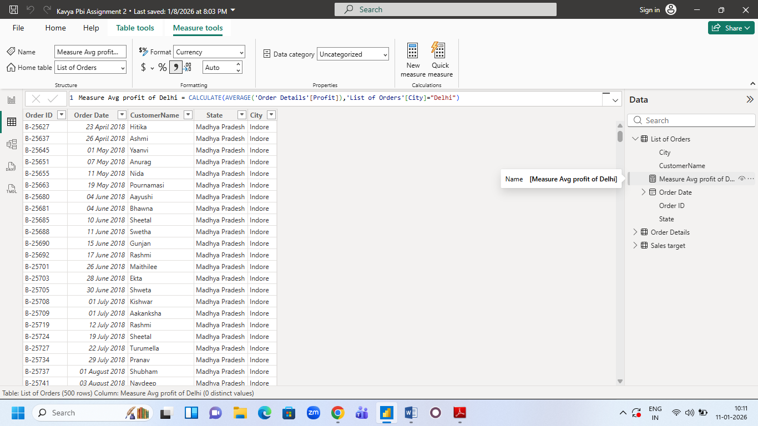
Calculate Year-to-Date (YTD) Sales: Define a measure to calculate the total sales amount accumulated from the earliest order date up to each order date. Measure YTD Sales = CALCULATE(SUM('Order Details'[Amount]),DATESYTD('List of Orders'[Order Date]))
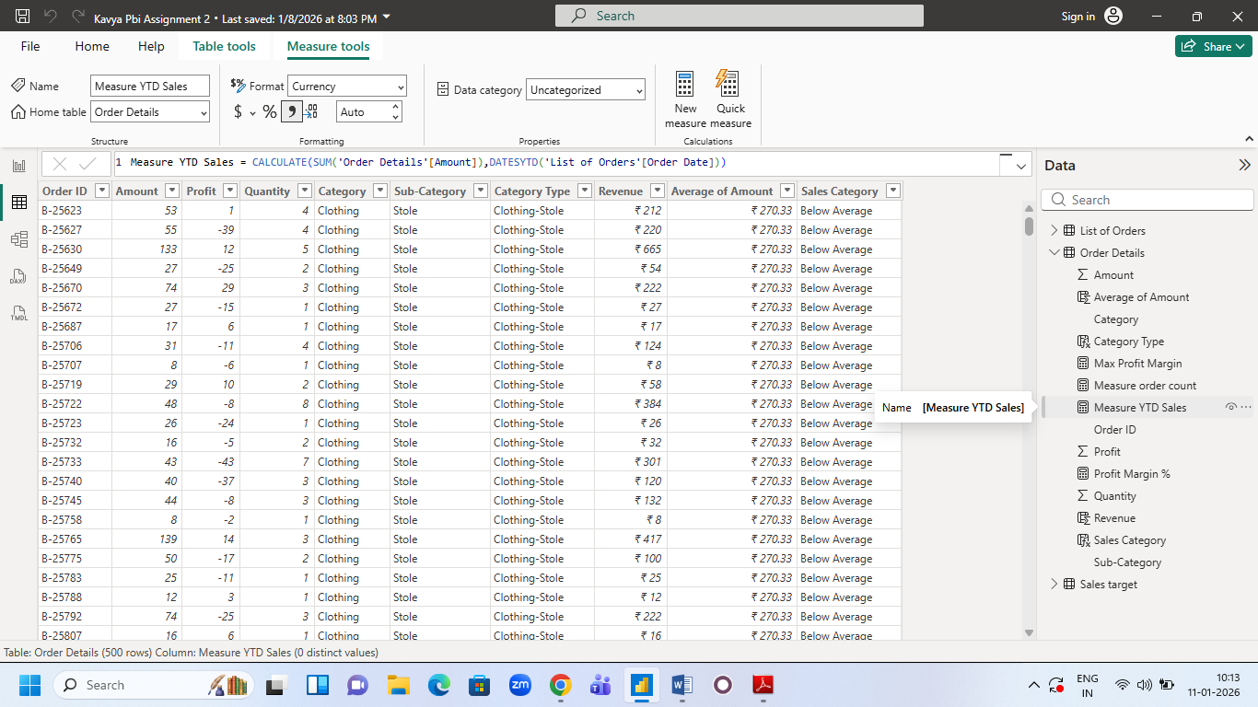

Sales Target Achievement by Category: Compare actual sales with sales targets by category using a clustered column chart.
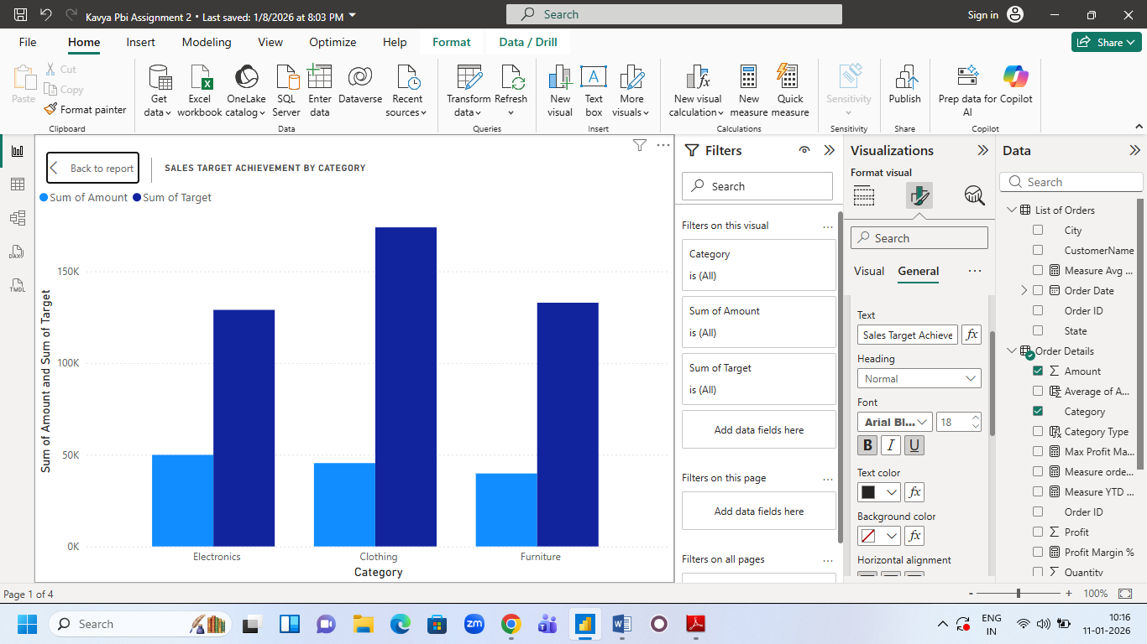

Max Profit Margin by Sub-Category: Analyze the maximum profit margin for each sub-category of products using a donut chart.
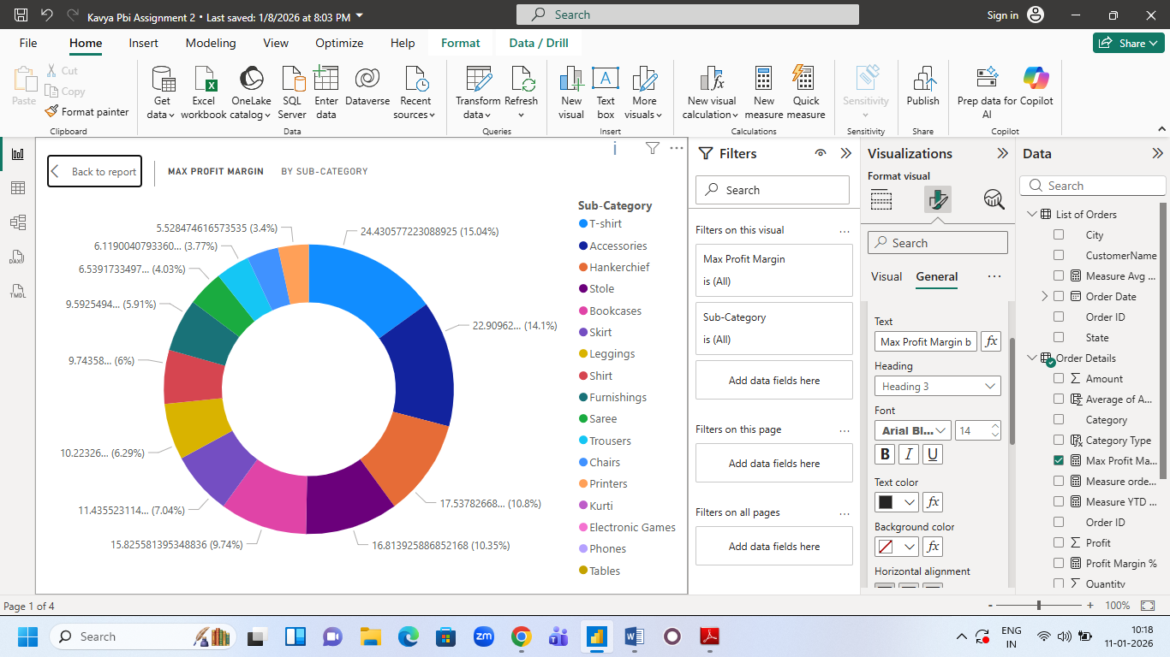

Monthly Sales Trend: Show the trend of monthly sales over time using a line chart.
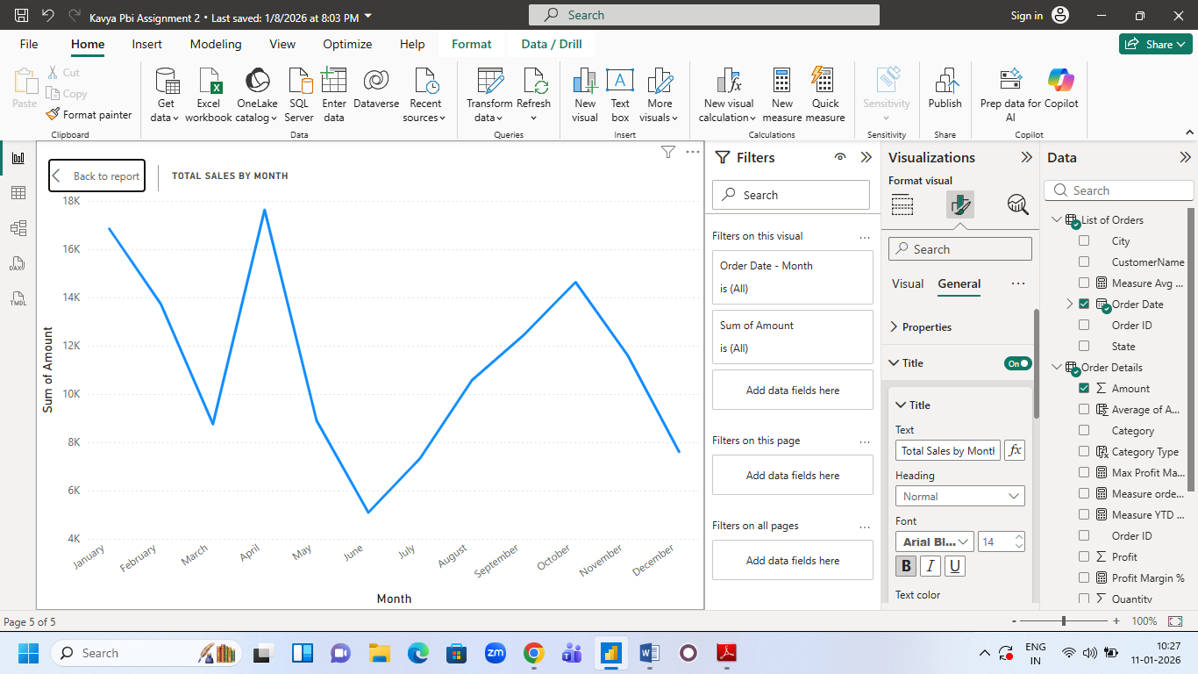

Comparison of Profit and Quantity by Sub-Category: Compare the relationship between profit and quantity sold for different sub-categories using a scatter chart.
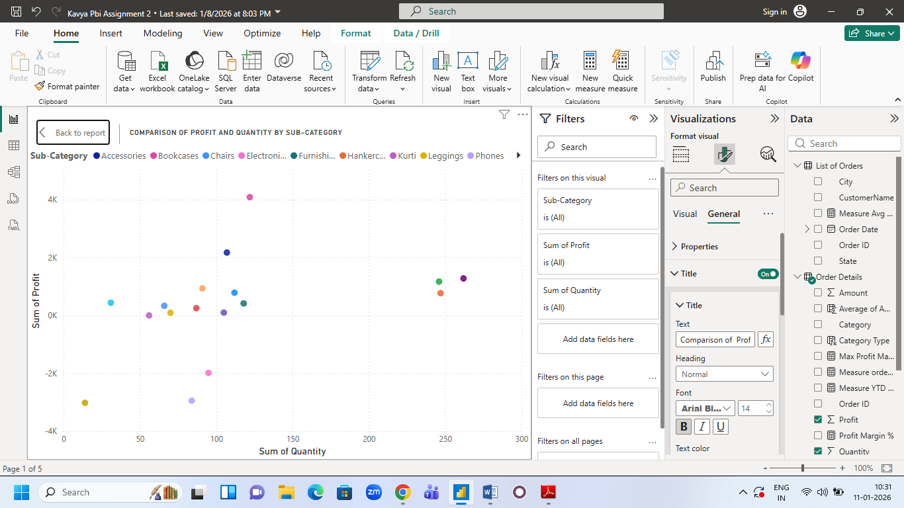

Comparison of Total Sales Amount and Target: Create cards to succinctly display the total sales amount alongside the sales target for quick comparison and analysis. Also, create a multi-row card to display the minimum target for each segment.
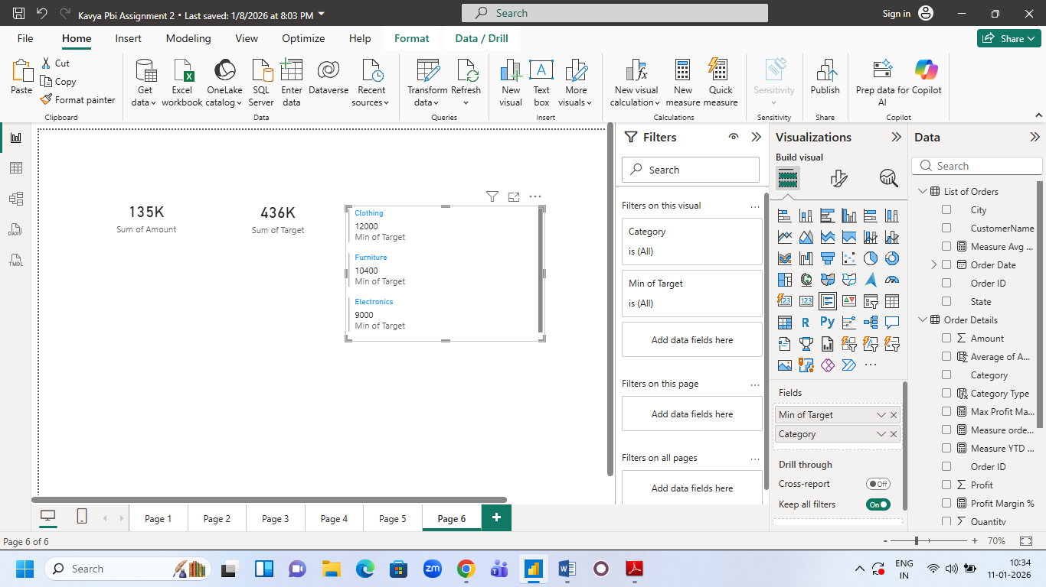

Sales Performance Matrix: Build a matrix view to analyze how actual sales compare to sales targets across different categories and months.
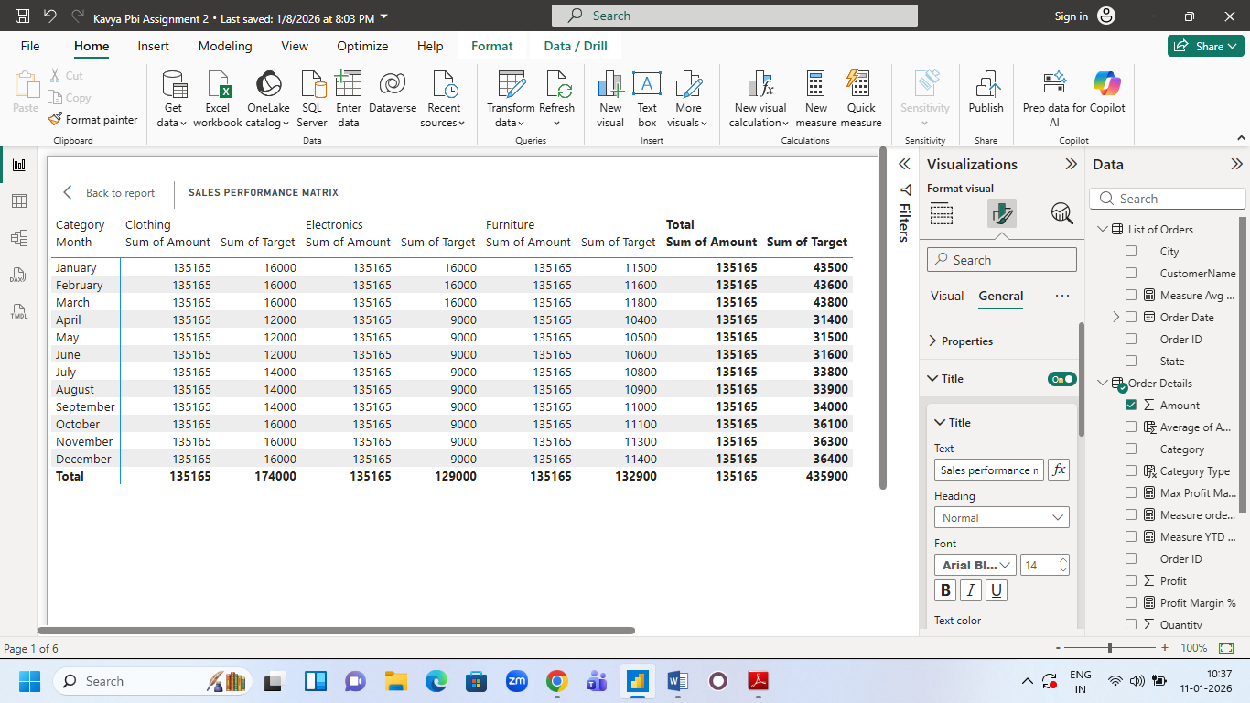

Geographic Sales Analysis: Visualize total sales on a map by city to identify regional sales patterns.
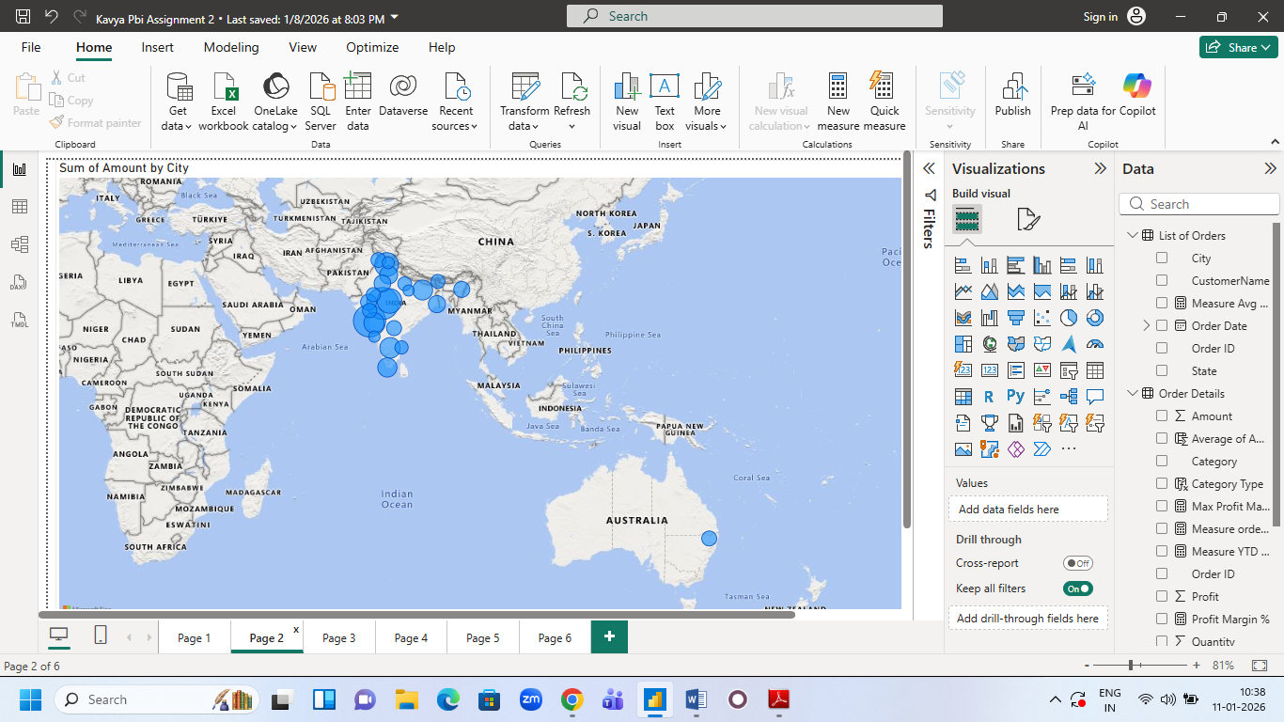

Sales Distribution by Sub-Category: Represent the sales distribution across different sub-categories using a treemap.
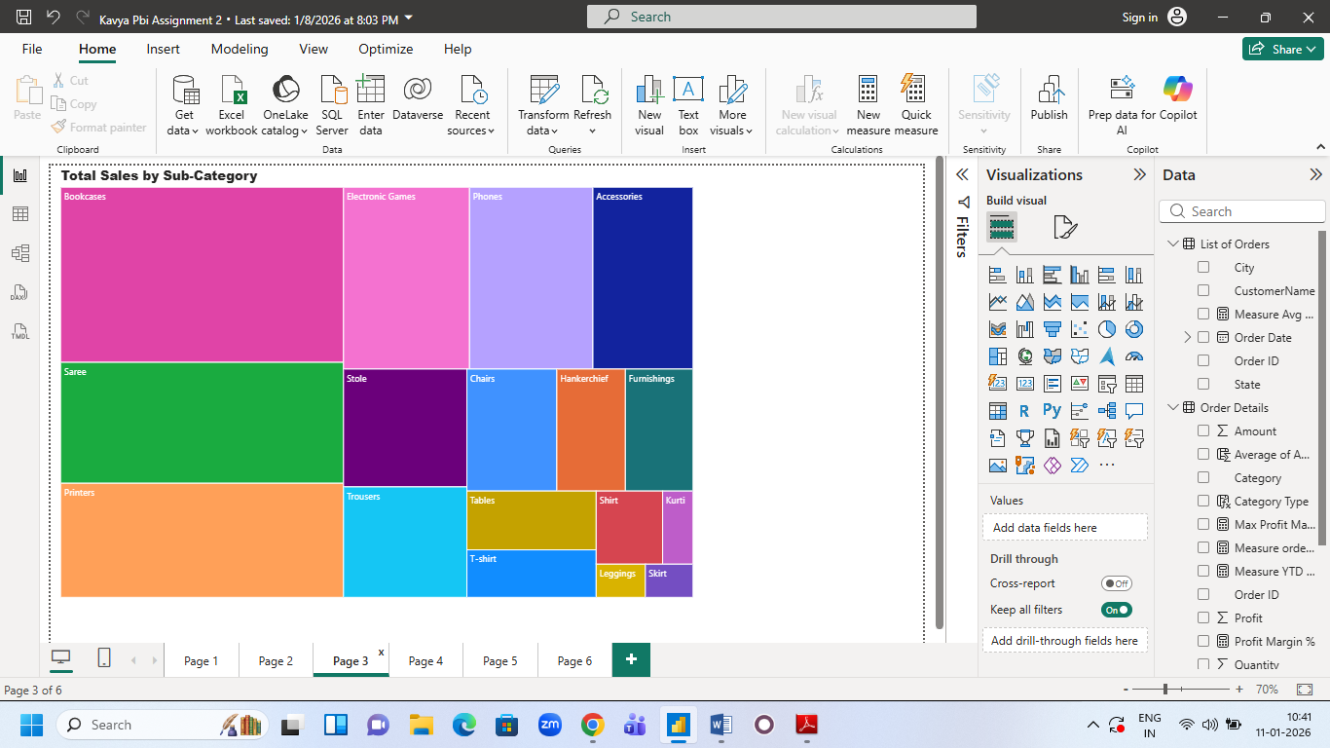

Order Count Analysis by State: Create a funnel chart to visualize the distribution of order counts across different states.
